Title: | Window Lifter

History
Issue status  (Index) | Maturity/Date  (draft/invalid/valid)  (dd-mmm-yyyy) | Author  Department | Check/Release  Department | Description
1.0 | Draft  24-0ct-17 | Habib Alejandro Apez González.  Estefanía López Villagómez. | Continental Engeeniers. | Window Lifter is a project  Simulates a car window.  This one shalls do the up and down movement.  This system should to have an communication with external components.

Table of Contents
1 Purpose 3
2 Definitions and abbreviations 3
3 Realization constraints and targets 3
4 SW Conceptual design 3
5 SW Component internal breakdown 4
5.1 Functional Decomposition 4
5.2 Function <Type> <function name> (type par 1, .., type par n) 5
5.3 Function <Type> <function name> (type par 1, .., type par n) 5

Purpose
A power window lifter is an automobile part which can be manipulated to up or down and other specific safety use control.

This project will work using two push buttons, one for the up movement, and the other one to down, these specific buttons are going to order to our product to simulate the window movement.

Represented with a ten segment red light bar, this light will turn on to be a complete close window or turn off to get down as the user will wanted.

There is to an extra function: Anti pinch this is a safety requirement than works only when the up movement is activated to prevent some kind of accidents, this stops the other move and make than our window down completely and remain stop for 5 seconds. Then our normal process continues.

The process our all the functions are scheduled in layers: MAL, HAL, APP. To simplify the final operations and delimit the functions with the option to continue adding other future operations.

Definitions and abbreviations
Definitions
GPIO | General-Purpose Input/Output

Abbreviations
Only SW Component specific abbreviations.
References
N° | Document name | Reference
1 | Window lifter requirements.docx | Continental

Realization constraints and targets

-Use a S32K144 microcontroller

SW Conceptual design
To make a conceptual design identify the product functions and the programs parts needed to produce them.
- Identifie all relevant parts in a system or sub-system.
- Define which parts are inside & outside the system boundary
- Define de interfaces between these parts, but also interfaces with neighboring systems and environment.

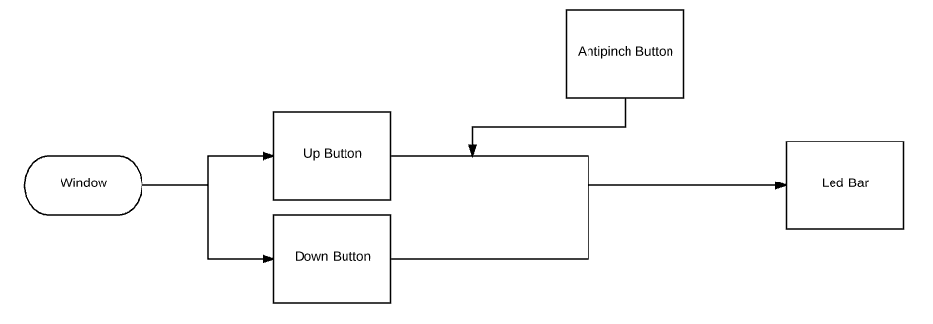

SW Component internal breakdown
For complex SW Components, the designer may define SW Subcomponents. Please consider also the work step "Deal with complexity" provided by the method for Detailed SW Design.
Note: SW Subcomponents are synonymous with the previous used term "Module"
Mapping to the file structure:
- Non complex SW Components should be represented by one object file.
- For complex SW Components each SW Subcomponent should be represented by one object file.
<Subcomponent decomposition if applicable>

Functional Decomposition
Overview of functions and their dependencies shown by a Static Function Tree
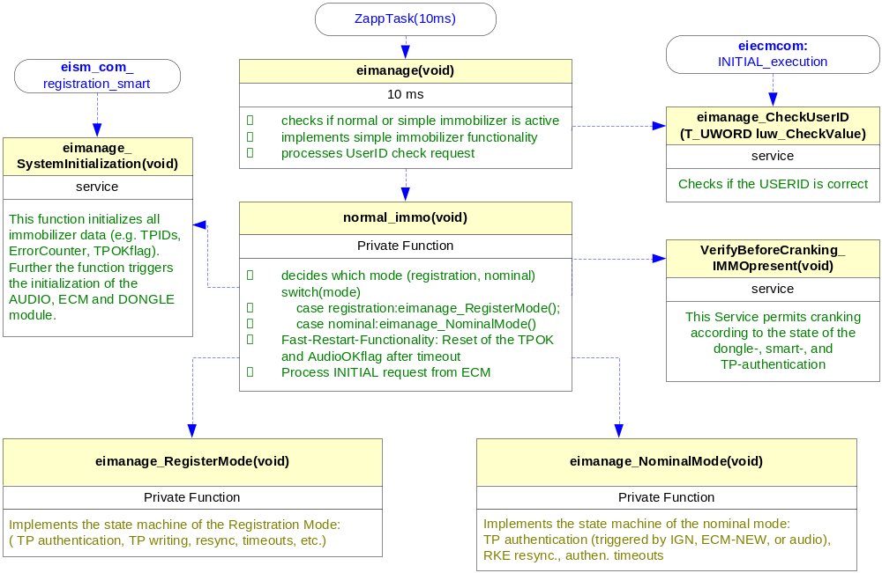
Function Description and Dynamic Behavior
Provide detailed static and dynamic description of all functions of the SW Component.
Functions which are defined in other SW Components shall only be referenced in the external interface description!
The signature description shall be done inside the function header in the source code.
For each function, the following section should be copied

Function <Type> <function name> (type par 1, .., type par n)

Description | Brief description of the function behavior and useful remarks
Parameter 1  <input| output| inout> | Give an explanation if the parameter shall be checked by the user, or if a check is implemented in the function here
Parameter 2..n
Return Value
Precondition | e.g. Function can only be called in a certain state, SW component is initialized  Relation between input parameters where applicable (Input for Module Test)
Post condition | e.g. specific State change e.g. car is locked, EEPROM Values written,  Relation between output parameters where applicable
Error Conditions

Dynamic Behavior
State Chart¹, Flow Chart¹
¹ Preferred
In this document, the dynamic behavior shall be designed on an abstract level showing the principle workflow of a function. Do not show the detailed implementation to ensure that the design description can be maintained with a reasonable effort. The target is not to show the complete detailed implementation 1:1.
The detailed design shall reflect in detail what a function is doing from a black box view. The internal details are useful on an abstract, but not very detailed level.
If the function is not complex a short textual description might be sufficient and a graphical description is not needed.
Symbol and function names shall be self explaining.
The link to the implementation may be provided by using the same names as in the design or by a comment showing the full name followed by the declaration showing the implementation.

Function <Type> <function name> (type par 1, .., type par n)
Description | Brief description of the function behavior and useful remarks
Parameter 1
<input| output| inout>
Parameter 2..n
Return Value
Precondition | e.g. Function can only be called in a certain state, SW component is initialized  Relation between input parameters where applicable (Input for Module Test)
Post condition | e.g. specific State change e.g. car is locked, EEPROM Values written,  Relation between output parameters where applicable
Error Conditions

Dynamic Behavior
State Chart¹, Flow Chart¹, Nassi Shneiderman
¹ Preferred
In this document, the dynamic behavior shall be designed on an abstract level showing the principle workflow of a function. Do not show the detailed implementation to ensure that the design description can be maintained with a reasonable effort. The target is not to show the complete detailed implementation 1:1.
The detailed design shall reflect in detail what a function is doing from a black box view. The internal details are useful on an abstract, but not on a very detailed level.
Symbol and function names shall be self explanatory.
The link to the implementation may be provided by using the same name as in the design or by a comment showing the full name followed by the declaration showing the implementation.

